Basic steps for running a survey project in Qualtrics:
Please be aware there is also a Qualtrics basic survey overview at https://www.qualtrics.com/support/survey-platform/survey-module/survey-module-overview/ and a ‘help’ icon in Qualtrics circled below in Qualtrics to use if unsure how to do something:
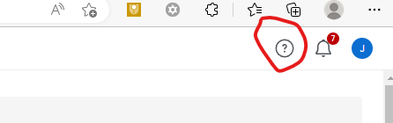

- Login to Qualtrics at https://curtin.au1.qualtrics.com/login?path=%2FControlPanel%2F%3F&product=ControlPanel
- Click on the main menu icon in the top left corner:

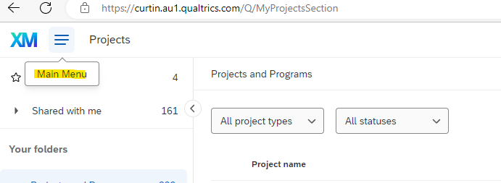
- Click on ‘Create project’ in the top right corner:
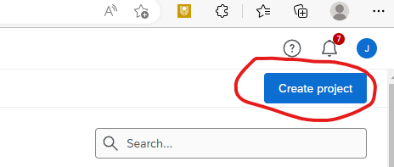
- Click on ‘Survey’ beneath Create a project:
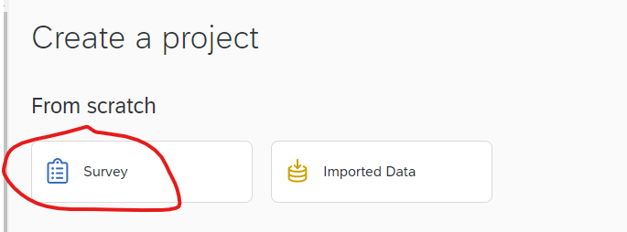
- Click on ‘Get started’ in the bottom right corner:
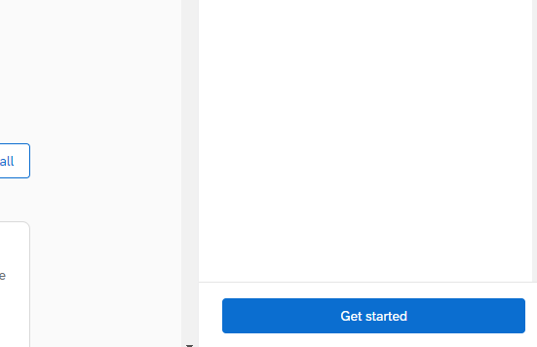

- Enter a name for the project and choose to either start your project by creating a blank survey project or by copying a previous survey. Then click on ‘Create project’.
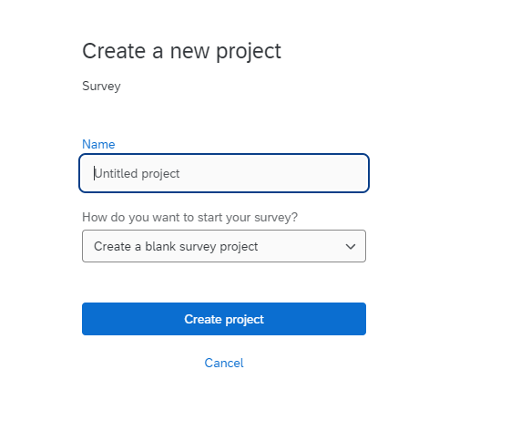
- Now it’s time to create the actual survey. Add in questions (which can appear in one single block or in multiple blocks). Use the left-hand controls to choose which kind of question and other options.
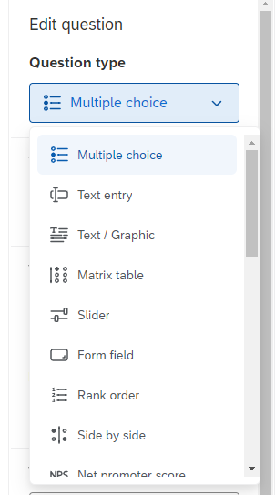
- With multiple choice questions, you can alter the number of choices and whether or not to allow one response only or multiple responses.
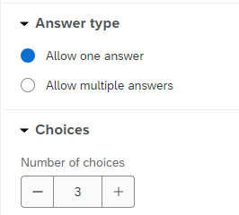
- Click on the actual question text to change the wording of the question and the responses:
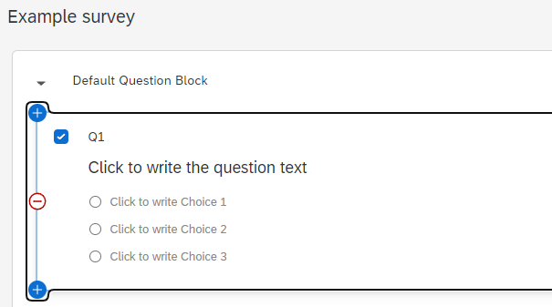
- Click on ‘+Add new question’ at the bottom right of the first question to add the next questions and so forth:
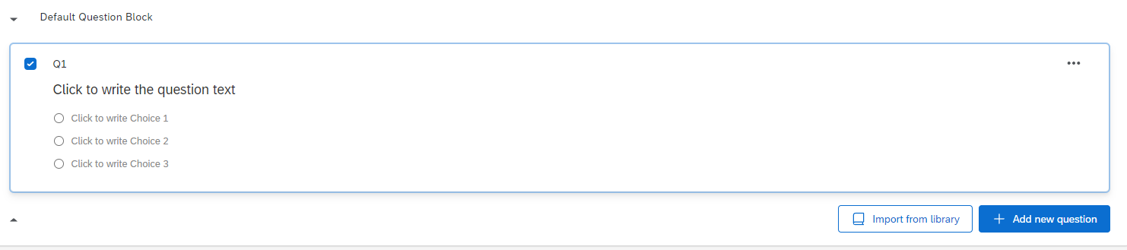
- You can use skip and display logic. For example, if you want a certain question just to be for respondents aged 17 year or older, you ask about their age group first then either skip the next question if under 17 (skip logic) or only display the next question if 17 or older (display logic). This is all straightforward to use. See below example:

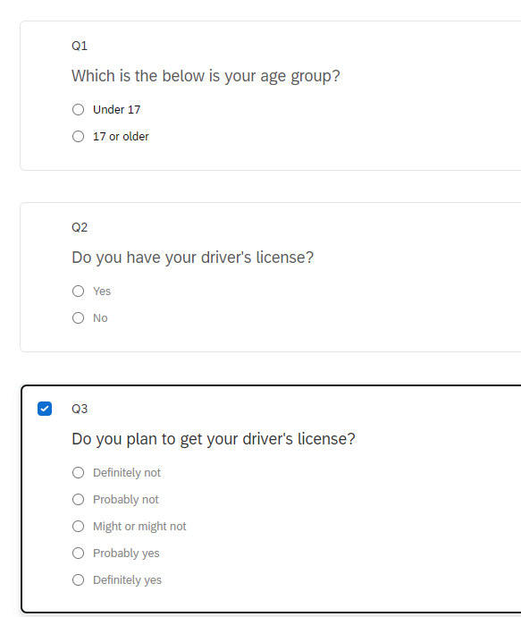
Display logic – only display Q2 if answer to Q1 is 17 or older:

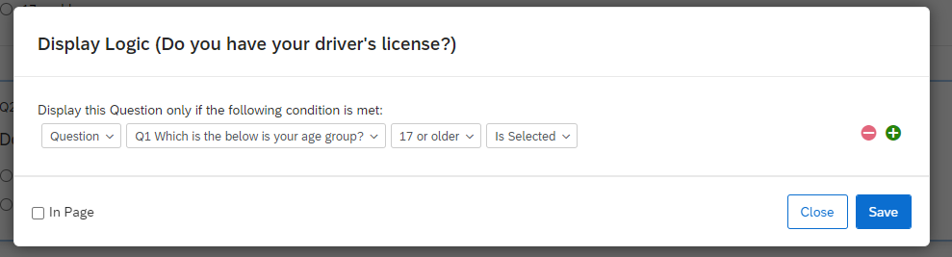

Skip logic – skip to Q3 if answer to Q1 is ‘under 17’:
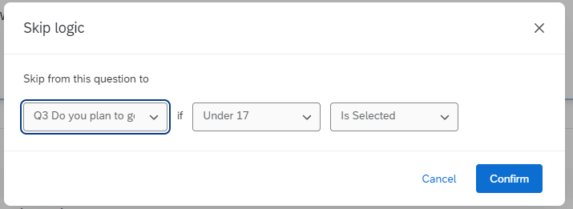

- You can click on the 3 dots at the top right of questions to move the question, delete the question, copy the question and add a page break (among other choices):
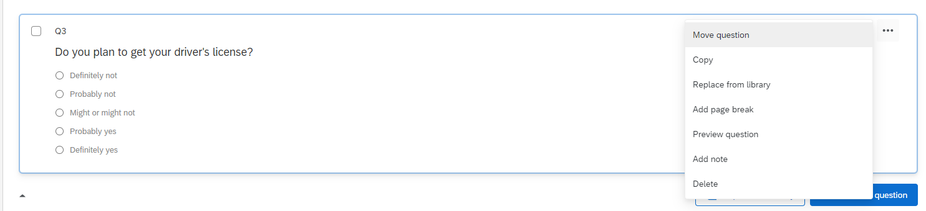
- You can put the questions in blocks (this is especially useful for skip and display logic as you may want certain people to skip a whole block of questions):
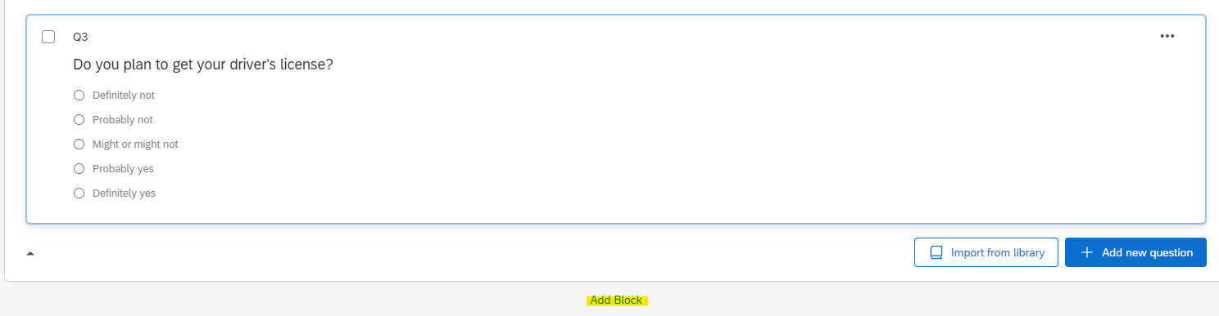
- You can re-name the block to make it easier to remember what it is (just click on Block 1 for example, and you can type a new name for it):
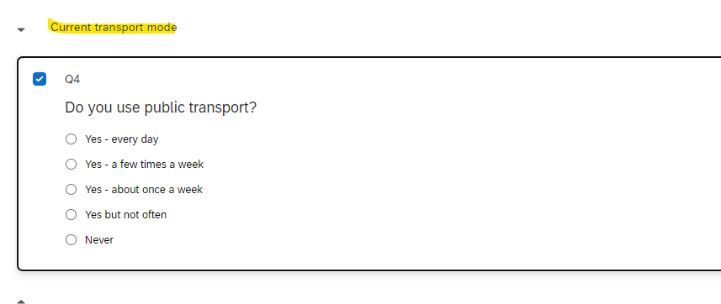
- You can use a matrix question (this is a nice condensed format):
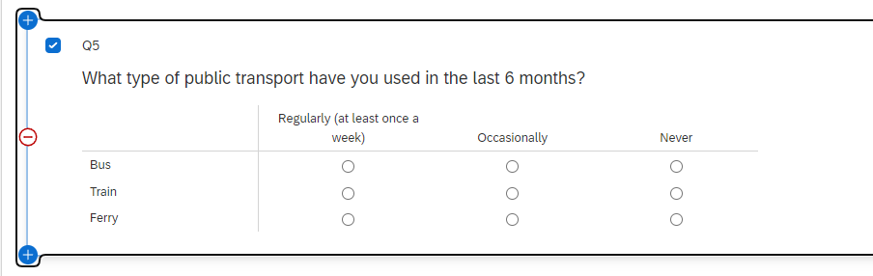

- With text entry questions, you can set them for a single or multiple lines or essay:
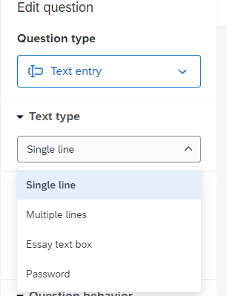
- When the survey is created, click on ‘Publish’ in the top right corner to make it live:
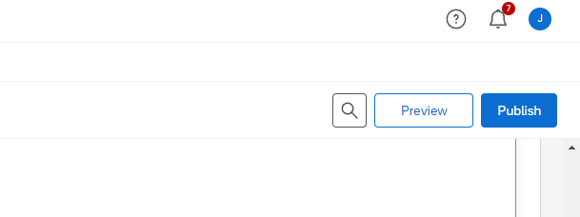
- To get the URL for distribution of the survey link, click on the ‘Distributions’ tab, then click on ‘Get single reusable link’ to get the URL:
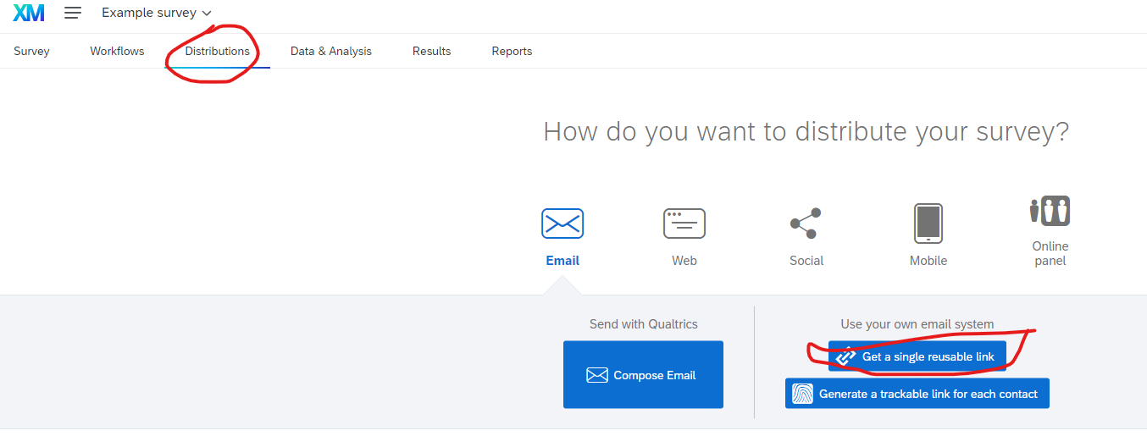
- By default, new surveys are set to ‘paused response collection’ so you need to click on ‘Resume response collection’ before you can get the link:
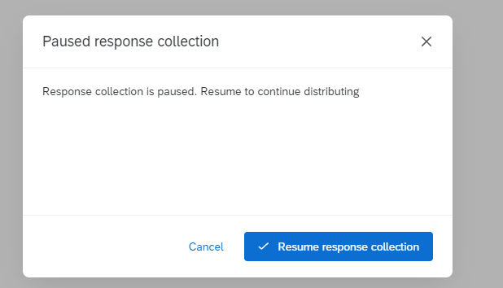
- Then an anonymous survey link will appear (which you can click on ‘Copy survey link’ to copy for pasting into your email):
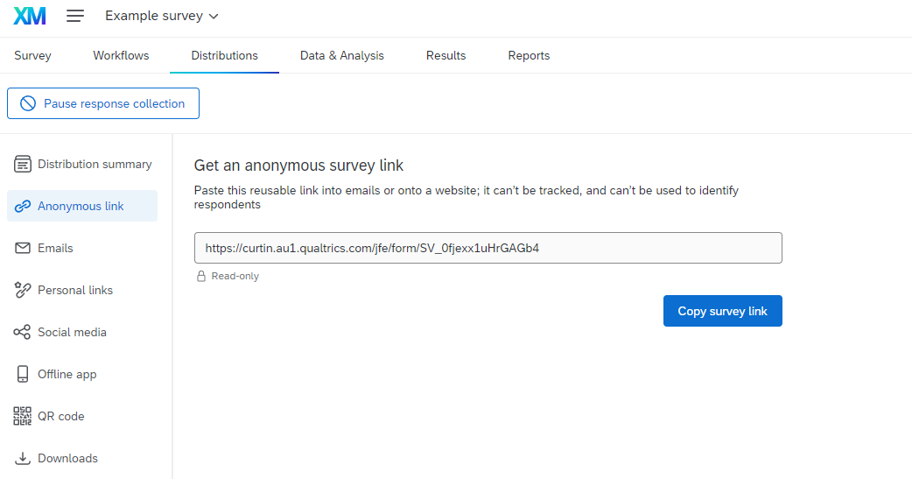
- Once the survey is distributed, you can check on and/or download the responses data by clicking on ‘Data & Analysis”:
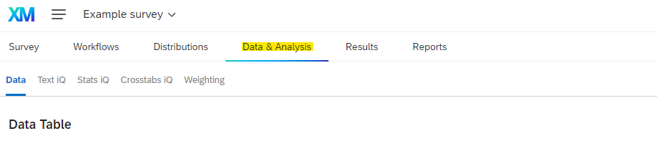
- Then click on ‘Export & Import’ and choose ‘Export Data’. This then enables you to export the data (you can choose between different data file types):
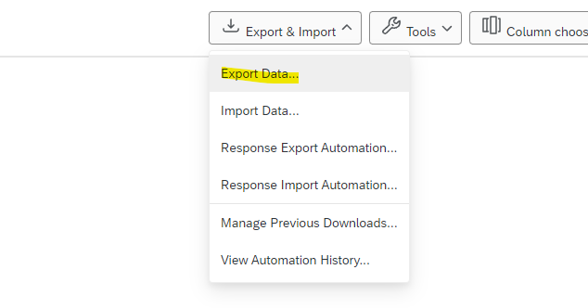
- It’s best to stop data collection when you’ve finished the project (do this by going to the ‘Distributions’ tab then clicking on ‘Pause response collection’:
